STREAMLINING TICKET ASSIGNMENT FOR EFFICIENT SUPPORT OPERATIONS

Team ID : 69a841ff105322f33864a53f
Team Size : 4
Team Leader : Dharshini H
Team member : VENKATESH MARIKKANNU
Team member : Baranikumar B
Team member : Naveen kumar G

Problem Statement:
Support teams often face delays and inefficiencies due to manual or unstructured ticket assignment. This leads to longer resolution times, uneven workload distribution, and reduced customer satisfaction.
Without streamlined processes, tickets risk being mishandled, duplicated, or unresolved, creating operational bottlenecks and negatively impacting overall support quality.

Objective:
The objective is to implement an automated, efficient ticket
assignment system that ensures fair workload distribution, faster response times, and improved customer experience. By streamlining allocation, the project aims to optimize support operations, reduce backlog, enhance agent productivity, and ensure each issue is promptly assigned to the most suitable support agent.

Skills:
Key skills include workflow automation, customer support tools
(Zendesk, Freshdesk, ServiceNow),data analysis for workload balancing, process optimization, project management, and strong communication. Knowledge of scripting (Python, SQL) or integration (APIs) is valuable. Soft skills such as problem-solving, teamwork, and adaptability are essential to ensure successful adoption and continuous improvement.

IDEATION PHASE:
Purpose: Identify and define the core problem.

Description: The team recognized inefficiencies in manual ticket assignment that caused delays, uneven workload distribution, and poor customer satisfaction. The idea was to automate ticket routing using ServiceNow, ensuring faster and fairer assignment of support tickets to the right teams.

Key Output: Clear problem statement and project objective focused on operational efficiency and automation.

Project Planning Phase:
Purpose: Define resources, tools, and roles required.

Description:
During planning, the team identified the skills (ServiceNow, automation, Python, SQL), tools, and roles for development. They also outlined the sequence of tasks such as creating users, groups, roles, and flow configurations.

Key Activities:

- Define roles and responsibilities (e.g., team leader and members)
- Plan for ServiceNow setup
- Establish workflow stages (user creation → group setup → automation flow)

Output: A step-by-step plan for system configuration and automation setup.

Project Design Phase :
Purpose: Structure the system and data flow.

Description: The team designed how tickets move within ServiceNow—from creation to automatic assignment.

- Created tables (like “Operations related”) with defined columns.
- Designed user groups (Platform, Certificate).
- Developed roles with access control (ACLs).

Key Design Elements:

- Flow diagrams (using Flow Designer)
- Field mappings (issue type → assigned group)
- Role-based access structure

Output: Functional and data design ready for implementation.

Requirement Analysis:
Purpose: Identify functional and non-functional needs.

Functional Requirements:

- System must auto-assign tickets based on issue type.
- Each ticket must be linked to a user and a support group.
- Admins should control access and manage groups.

Non-Functional Requirements:

- System should be reliable and respond in real-time.
- User-friendly ServiceNow interface.
- Secure role-based access control.

Output: Comprehensive understanding of system needs before building workflows.

Performance Testing :
Purpose: Validate that automation works efficiently.

Description:
Performance testing ensured that the Flow Designer automation correctly assigns tickets without delay or errors.

- Test cases included different issue categories like “Unable to login,” “404 Error,” etc.
- Verified that each issue type was routed to the correct group (Platform or Certificates).

Metrics Evaluated:

- Response time for ticket assignment
- Accuracy of group mapping
- System stability during concurrent ticket creation Output: Confirmation that automated routing improves response time and efficiency

Create Users
- Open service now.
- Click on All >> search for users
- Select Users under system security
- Click on new
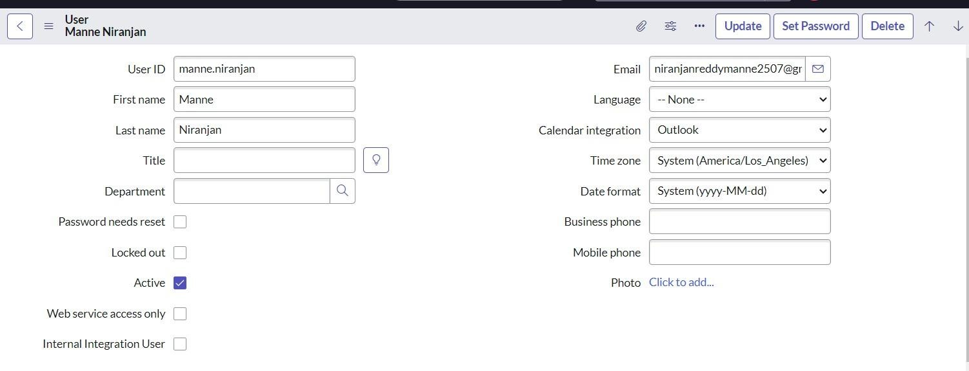
- Fill the following details to create a new user

- Click on submit Create one more user:
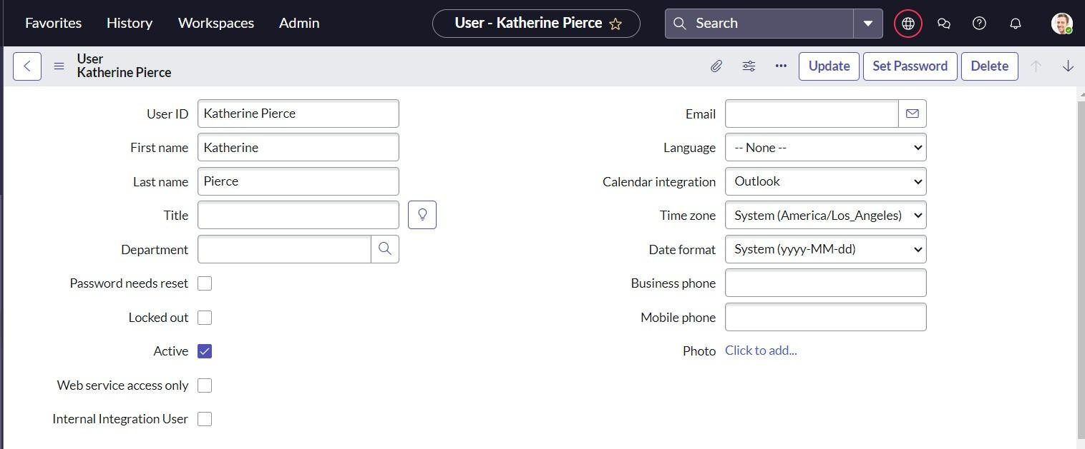
- Create another user with the following details
- Click on submit

Create Groups

- Open service now.
- Click on All >> search for groups
- Select groups under system security
- Click on new
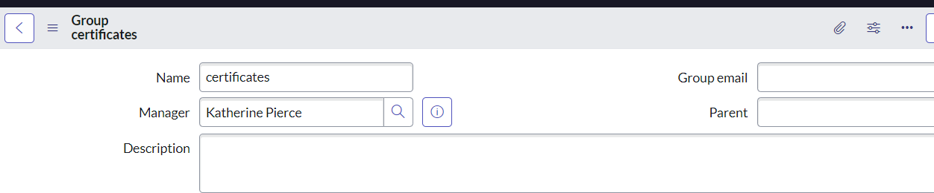
- Fill the following details to create a new group

- Click on submit

Create one more group:

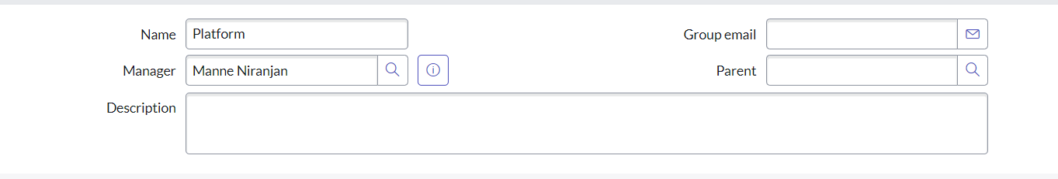
- Create another group with the following details
- Click on submit

Create roles
- Open service now.
- Click on All >> search for roles
- Select roles under system security
- Click on new
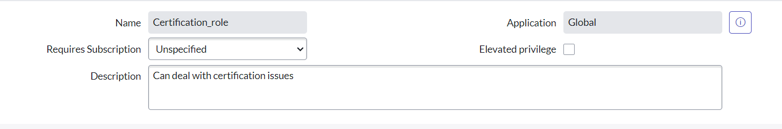
- Fill the following details to create a new role
- Click on submit

Create one more role:

Create another role with the following details

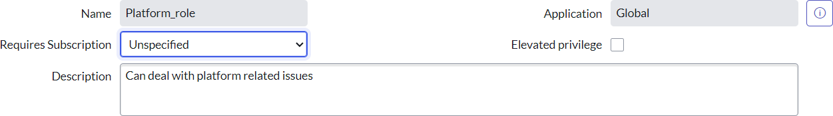

Click on submit

Create Table
- Open service now.
- Click on All >> search for tables
- Select tables under system definition
- Click on new
- Fill the following details to create a new table Label : Operations related
Check the boxes Create module & Create mobile module
- Under new menu name : Operations related
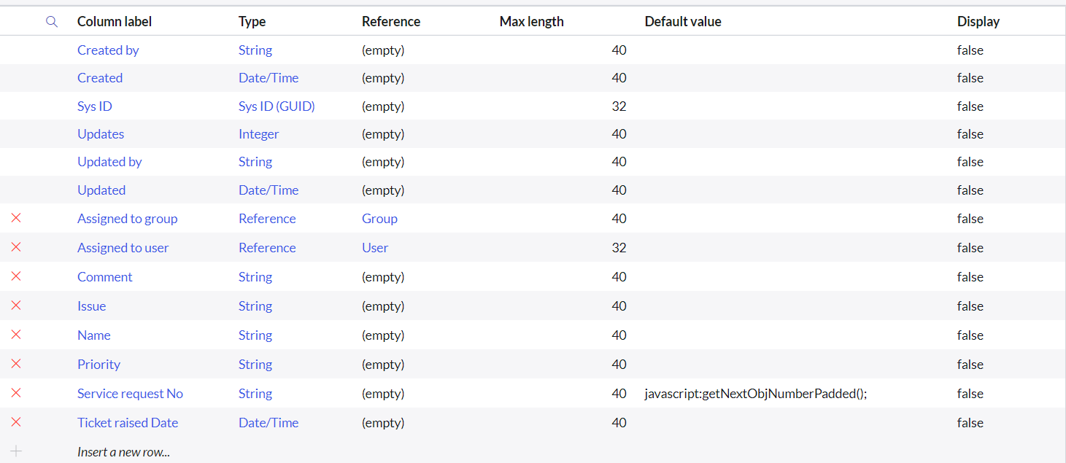
- Under table columns give the columns

- Click on submit
Create choices for the issue filed by using form design Choices are

  - unable to login to platform
  - 404 error
  - regarding certificates
  - regarding user expired

Assign roles & users to certificate group
- Open service now.
- Click on All >> search for tables
- Select tables under system definition
- Select the certificates group
- Under group members
- Click on edit
- Select Katherine Pierce and save
- Click on roles
- Select Certification_role and save

Assign roles & users to platform group
- Open service now.
- Click on All >> search for tables
- Select tables under system definition
- Select the platform group
- Under group members
- Click on edit
- Select Manne Niranjan and save
- Click on roles
- Select Platform_role and save

Assign role to table
- Open service now.
- Click on All >> search for tables
- Select operations related table
- Click on the Application Access
- Click on u_operations_related read operation
- Click on the profile on top right side
- Click on elevate role
- Click on security admin and click on update
- Under Requires role
- Double click on insert a new row
- Give platform role
- And add certificate role
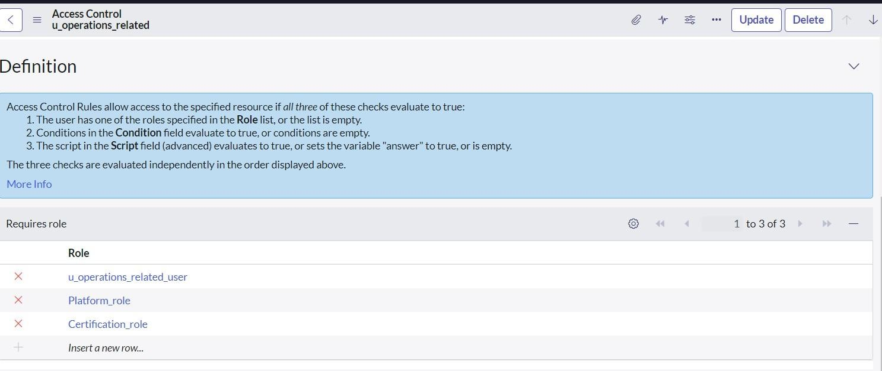
- Click on update
- Click on operations_related write operation
- Under Requires role
- Double click on insert a new row
- Give platform role
- And add certificate role

Create ACL
- Open service now.
- Click on All >> search for ACL
- Select Access Control(ACL) under system security
- Click on new
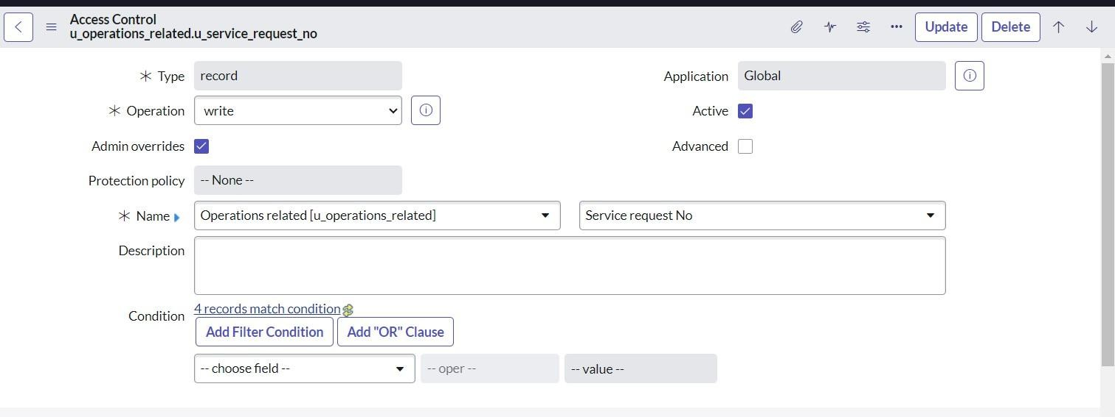
- Fill the following details to create a new ACL
- Scroll down under requires role
- Double click on insert a new row
- Give admin role
- Click on submit
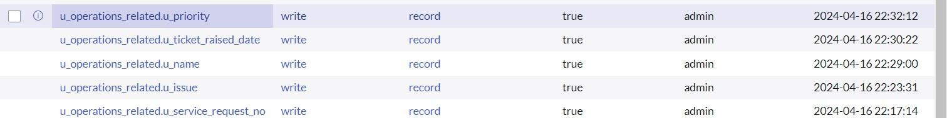
- Similarly create 4 acl for the following fields

Create a Flow to Assign operations ticket to group
- Open service now.
- Click on All >> search for Flow Designer
- Click on Flow Designer under Process Automation.
- After opening Flow Designer Click on new and select Flow.
- Under Flow properties Give Flow Name as “ Regarding Certificate”.
- Application should be Global.
- Select Run user as “ System user ” from that choice.
- Click on Submit.
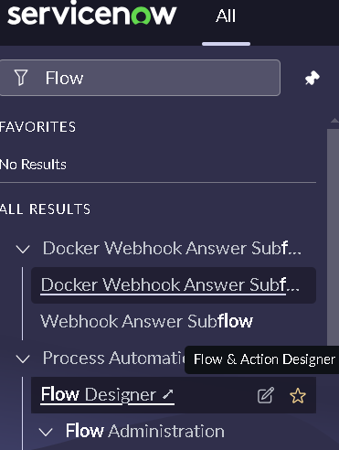

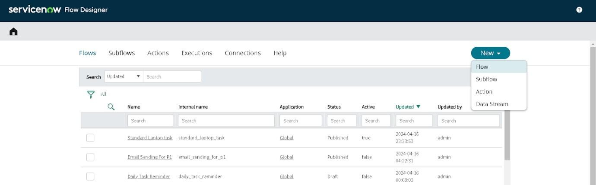
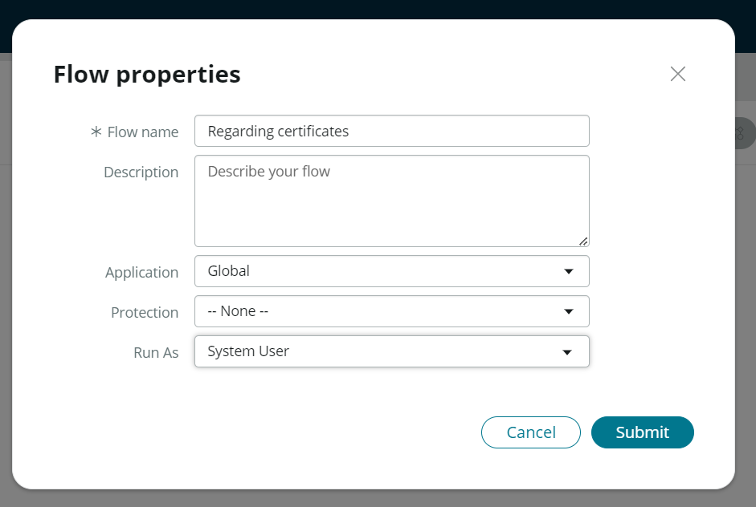

- Click on Add a trigger
- Select the trigger in that Search for “create or update a record” and select that.
- Give the table name as “ Operations related ”.
- Give the Condition as Field : issue
Operator : is
Value : Regrading Certificates
- After that click on Done.

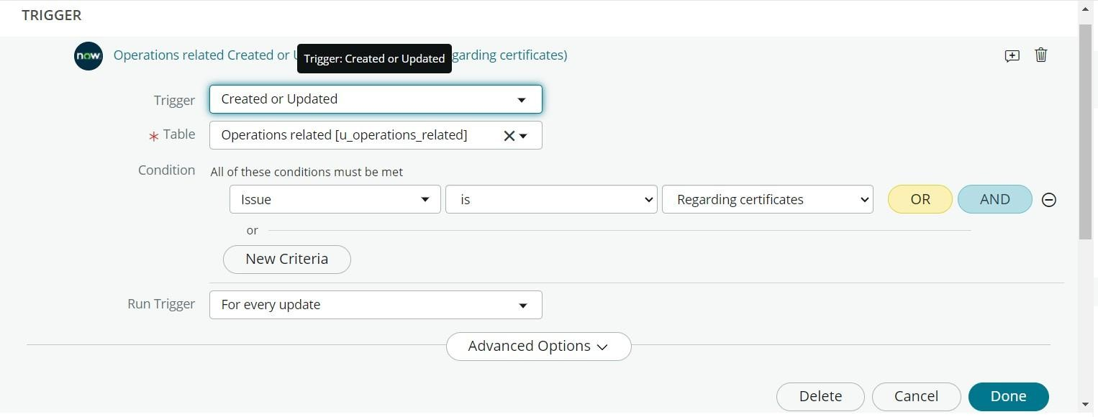
- Now under Actions.
- Click on Add an action.
- Select action in that search for “ Update Record ”.
- In Record field drag the fields from the data navigation from left side
- Table will be auto assigned after that
- Give the field as “ Assigned to group ”
- Give value as “ Certificates ”
- Click on Done.
- Click on Save to save the Flow.
- Click on Activate.
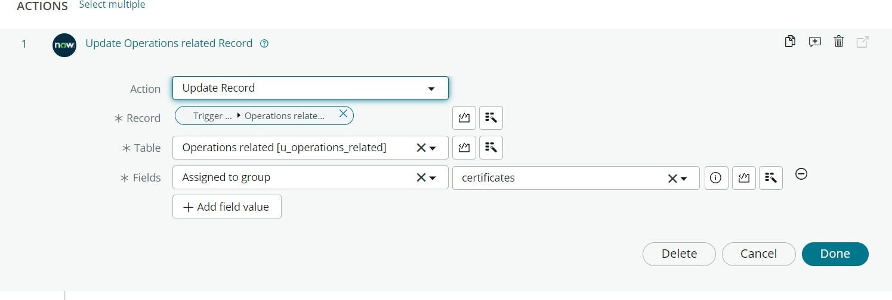

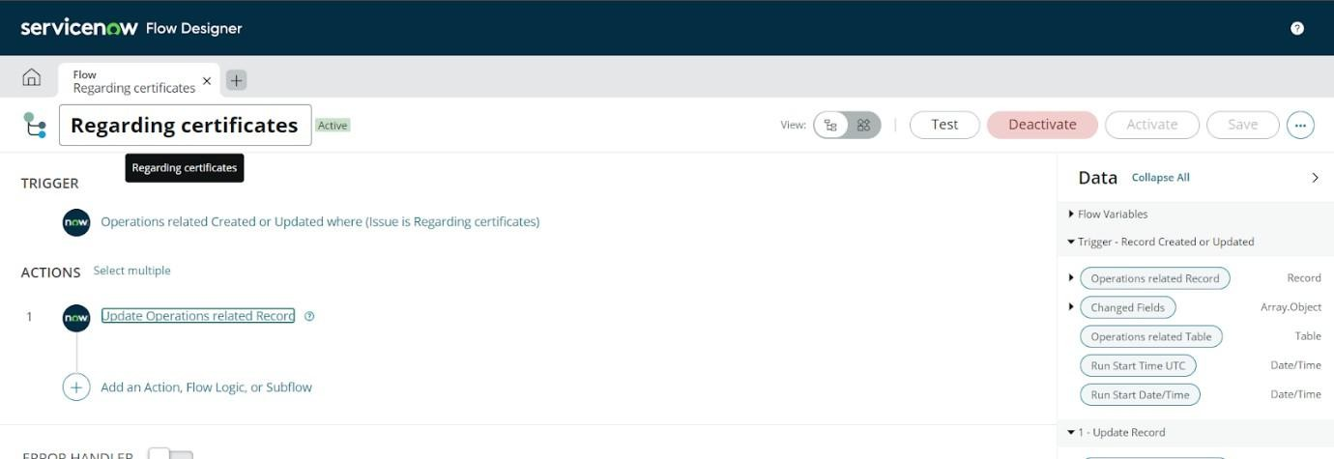

Create a Flow to Assign operations ticket to Platform group

  - Open service now.
  - Click on All >> search for Flow Designer
  - Click on Flow Designer under Process Automation.
  - After opening Flow Designer Click on new and select Flow.
  - Under Flow properties Give Flow Name as “ Regarding Platform ”.
  - Application should be Global.
  - Select Run user as “ System user ” from that choice.
  - Click on Submit.

- Click on Add a trigger
- Select the trigger in that Search for “create or update a record” and select that.
- Give the table name as “ Operations related ”.
- Give the Condition as Field : issue
Operator : is
Value : Unable to login to platform

- Click on New Criteria Field : issue
Operator : is Value : 404 Error

- Click on New Criteria Field : issue

Operator : is
Value : Regrading User expired

- After that click on Done.
- Now under Actions.
- Click on Add an action.
- Select action in that search for “ Update Record ”.
- In Record field drag the fields from the data navigation from left side
- Table will be auto assigned after that
- Give the field as “ Assigned to group ”.
- Give value as “ Platform ”.
- Click on Done.
- Click on Save to save the Flow.
- Click on Activate.

CONCLUSION:
The implementation of the automated ticket routing system at ABC Corporation has been a significant success. By leveraging the capabilities of ServiceNow, we have streamlined the process of assigning support tickets to the appropriate teams, addressing the challenges of manual routing, and ensuring timely resolution of issues.

